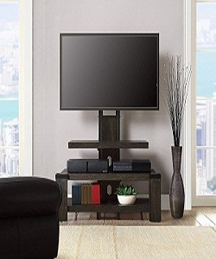

Stylish brown TV-trolley

$98.03

Availability: In stock

### Description

Create classic-factor to your room with Poliform Stylish brown TV-trolley is designed with a lavish modern style in premium linen upholstery. Ribbed tufted headboard and oak colored legs. Poliform French Provincial furniture are unique pieces for your home. This range includes Classic Dressers, TV Units, Desks, and a Bedroom Collection that will look stunning in your newly built or renovated home. Poliform bringing the best of French Provincial Furniture to Australia at the best prices!